Ideation Phase Define the Problem Statements
Date | 19 February 2025
Team ID | LTVIP2026TMIDS24568
Project Name | Online Payments Fraud Detection using Machine Learning
Maximum Marks | 2 Marks
Customer Problem Statement Template:
With the rapid growth of digital transactions such as UPI, credit card, and online banking payments, the risk of fraudulent transactions has significantly increased. Many users face unauthorized transactions, identity theft, and financial losses due to online payment fraud.
Traditional rule-based fraud detection systems are not always effective in detecting complex and evolving fraud patterns. Financial institutions require an intelligent system that can analyze transaction data and detect fraudulent activities in real time.
There is a strong need for a machine learning-based fraud detection system that uses historical transaction data to identify suspicious activities and prevent financial loss.
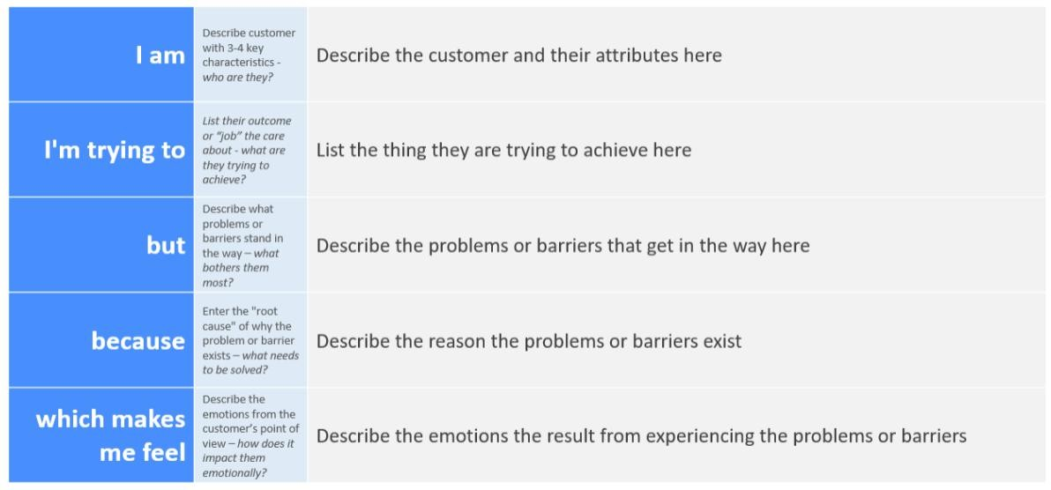
Reference: https://miro.com/templates/customer-problem-statement/
Example:
Problem  Statement (PS) | I am  (Customer) | I’m trying to | But | Because | Which makes me feel
PS-1 | Online  Payment  User | Make secure  digital  payments | My  transactio n gets blocked or misused | Fraudsters hack payment systems | Worried and insecure
PS-2 | Bank  Manager | Reduce fraud transactions | Fraud detection is not always accurate | Traditional systems miss complex fraud | Concerned about financial losses

Importance of Fraud Detection
- Online payment fraud detection is important because:
- It protects customers from financial loss
- It improves trust in digital payment systems
- It helps banks reduce operational risks
- It prevents unauthorized transactions

